2.4 Minimum SL for Detectability

2.4.1 Global Minimum of SL

To find the minimum of SL needed in order for the EFR to detect a response, we should first search the observations that the value of SL is larger than 0. Then we find there are 560 observations. Next, we based on different tests to find the minimum of SL. The results are in the following table.

|  |  |
| --- | --- |
| Method | Minimum of SL |
| F-test | 1.36 |
| Rayleigh-test | 3.46 |
| F-test & Rayleigh-test | 4.64 |

Table Global Minimum of SL

We find that based on the F-test the minimum 1.36 is the smallest. On the Rayleigh-test, the minimum is 3.46. And, on the combination of two tests, the minimum 4.64 is largest

2.4.2 Relationship between Minimum of SL and Carrier or Frequency Groups

2.4.2.1 Carrier

|  |  |  |
| --- | --- | --- |
| Method | Carrier | Minimum of SL |
| F-test | a_F1 | 4.9 |
|  | a_F2 | 6.71 |
|  | i_F1 | 3.46 |
|  | i_F2 | 6.36 |
|  | u_F1 | 13.66 |
|  | u_F2 | 6.2 |
|  | s | 4.64 |
|  | sh | 5.63 |
| Rayleigh-test | a_F1 | 4.9 |
|  | a_F2 | 6.71 |
|  | i_F1 | 8.46 |
|  | i_F2 | 1.36 |
|  | u_F1 | 8.66 |
|  | u_F2 | 6.2 |
|  | s | 4.64 |
|  | sh | 5.63 |
| F-test & Rayleigh-test | a_F1 | 4.9 |
|  | a_F2 | 6.71 |
|  | i_F1 | 8.46 |
|  | i_F2 | 6.36 |
|  | u_F1 | 13.66 |
|  | u_F2 | 11.2 |
|  | s | 4.64 |
|  | sh | 5.63 |

Table Relationship between Minimum of SL and Carrier

Based on the above table, I use three different colors to differ three levels of carrier: low, mid and high frequencies. The F1 carriers are low frequency dominant, the F2 carriers are mid frequency dominant and the fricatives (sh and s) are high frequency dominant.

In general, we can find that with the higher carrier, and will have the smallest minimum of SL. The lower the carrier is, the larger the minimum of SL.

Also, we can conclude that among F1 and F2 level, there are three different forms: “a”, “i”, and “u”. We find that for F1 level, these three kinds have a distinct difference in minimum of SL than that in F2 level. And “u” always has the largest minimum of SL, “a” always has the smallest minimum of SL.

2.4.2.2 Frequency Groups

In order to have a more detailed exploration of the problem how does the minimum SL vary by frequency group, we need to classify the carrier feature into three categories: low, mid and high.

Then we calculate the minimum of SL of each frequency again based on three different methods.

|  |  |  |
| --- | --- | --- |
| Method | Frequency Groups | Minimum of SL |
| F-test | low | 3.46 |
|  | mid | 6.2 |
|  | high | 4.64 |
| Rayleigh-test | low | 4.9 |
|  | mid | 1.36 |
|  | high | 4.64 |
| F-test & Rayleigh-test | low | 4.9 |
|  | mid | 6.36 |
|  | high | 4.64 |

Table Relationship between Minimum of SL and Frequency Groups

Based on the result in the table above, we find that based on the both two testing will always lead to the largest minimum of SL since in that way the criterion of finding the minimum of SL is stricter than other two.

And the relationship between minimum of SL and frequency groups are not as clear as that of carriers and this may be caused by the robust classification of frequency. (Frequency groups have only 3 levels but the carriers have 8 levels.)

2.4 Minimum SL for Detectability

2.4.1 Global Minimum of SL

To find the minimum of SL needed in order for the EFR to detect a response, we should first fit the following two models respectively on F-test and Rayleigh-test:





1. F-test

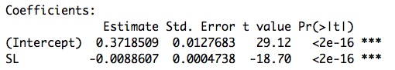

Table Global Minimum of SL on F-test

1. Rayleigh-test

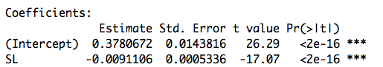

Table Global Minimum of SL on Rayleigh-test

1. Conclusions

|  |  |
| --- | --- |
| method | Minimum of SL |
| f-test | 37.02498 |
| Rayleigh-test | 36.0094 |

Table Comparison between F-test and Rayleigh-test

2.4.2 Relationship between Minimum of SL and Carrier or Frequency Groups

To find the relationship between minimum of SL needed in order for the EFR to detect a response and Carrier, we should fit the following two models respectively on F-test and Rayleigh-test:





* + - 1. Carrier

1. F-test

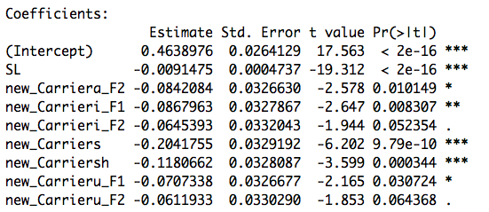

Table Relationship between Minimum of SL and Carrier on F-test

1. Rayleigh-test

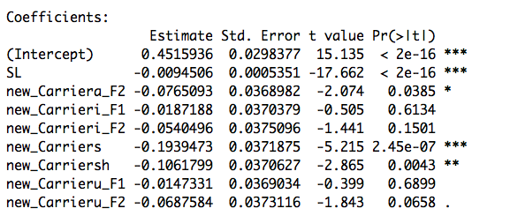

Table Relationship between Minimum of SL and Carrier on Rayleigh-test

1. Conclusions

Based on the above results of two tests, we can draw a table to find the minimum of SL based on different levels of Carrier:

|  |  |  |
| --- | --- | --- |
| Method | Carrier | Minimum of SL |
| F-test | a_F1 | 45.24707 |
|  | a_F2 | 36.04145 |
|  | i_F1 | 35.75854 |
|  | i_F2 | 38.19167 |
|  | u_F1 | 37.51449 |
|  | u_F2 | 38.55745 |
|  | s | 22.92671 |
|  | sh | 32.34014 |
| average of f-test |  | **35.8222** |
| Rayleigh-test | a_F1 | 42.49398 |
|  | a_F2 | 34.39828 |
|  | i_F1 | 40.51329 |
|  | i_F2 | 36.77481 |
|  | u_F1 | 40.93503 |
|  | u_F2 | 35.21843 |
|  | s | 21.97176 |
|  | sh | 31.25872 |
| average of Rayleigh-test |  | **35.4455** |

Table Comparison of Carrier between F-test and Rayleigh-test

Based on the above table, I use three different colors to differ three levels of carrier: low, mid and high frequencies. The F1 carriers are low frequency dominant, the F2 carriers are mid frequency dominant and the fricatives (sh and s) are high frequency dominant.

In general, we can find that with the higher carrier, and will have the smallest minimum of SL. The lower the carrier is, the larger the minimum of SL.

Also, we can conclude that among F1 and F2 level, there are three different forms: “a”, “i”, and “u”. We find that for F1 level, these three kinds have a distinct difference in minimum of SL than that in F2 level.

* + - 1. Frequency Groups

To find the relationship between minimum of SL needed in order for the EFR to detect a response and frequency groups, we should fit the following two models respectively on F-test and Rayleigh-test:





1. F-test

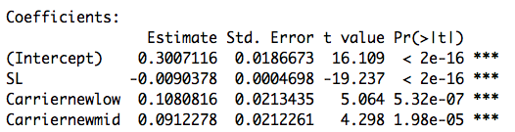

Table Relationship between Minimum of SL and Frequency Groups on F-test

1. Rayleigh-test

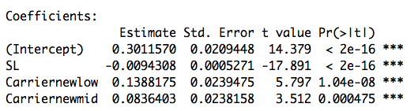

Table Relationship between Minimum of SL and Frequency Groups on Rayleigh-test

1. Conclusions

Based on the above results of two tests, we can draw a table to find the minimum of SL based on different levels of frequency groups:

|  |  |  |
| --- | --- | --- |
| Method | Frequency Groups | Minimum of SL |
| F-test | low | 39.69917 |
|  | mid | 37.83436 |
|  | high | 27.74034 |
| Rayleigh-test | low | 41.35116 |
|  | mid | 35.50042 |
|  | high | 26.63157 |

Table Comparison of Frequency Groups between F-test and Rayleigh-test

Based on the result in the table above, we find that based on the both of two testing, lowest level of frequency will always lead to the largest minimum of SL since in that way the criterion of finding the minimum of SL is stricter than other two.